In the early 1970’s, the Printing Industry of Central Ohio and the Columbus Club of Printing House Craftsmen came together and created the Franklinton Award. The first was awarded in 1974 and has continued each year to be presented to individuals or groups who have made outstanding public contributions to the Central Ohio community. This award, the highest recognition made by the Central Ohio graphic arts industry, honors Benjamin Franklin, the patron saint of the printing industry, who dedicated his life to the betterment of his community and country.
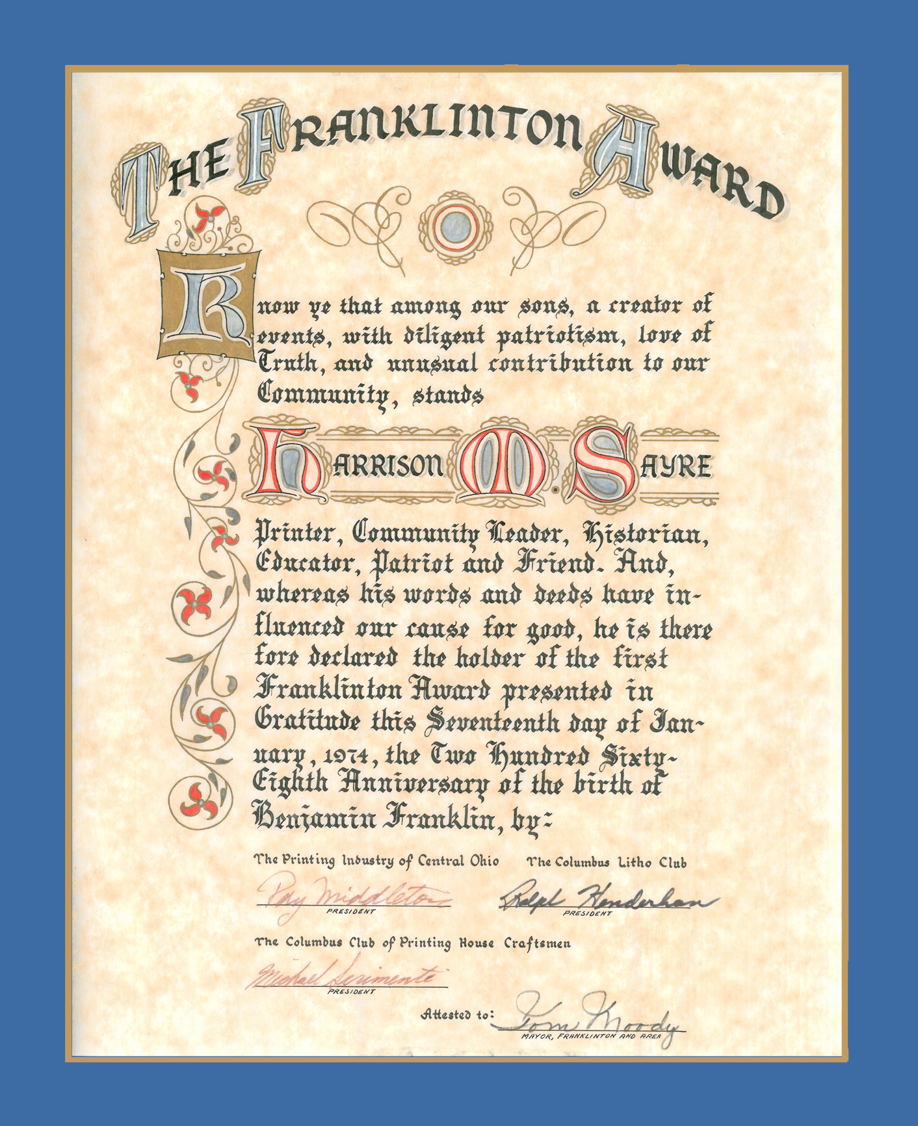

In 2008, Printing Industries of Ohio • N.Kentucky, now Graphic Media Alliance, began presenting this prestigious award to a member of the industry who had made significant contributions to our central Ohio graphic arts community, as opposed to a community leader/contributor. Winners of this award since this change include: Jim Hopkins, Hopkins Printing; Bill Stickney, former Printing Industries president; Robert Coyne, formerly of Coyne Graphic Finishing; Robert Boehm, Boehm, Inc.; Gene Scott, PXPOHIO; David Pilcher Sr., Freeport Press; David Olberding, Phototype; Frank Coriell, Veritiv; Dave Marsh, West-Camp Press; Mary Held and Sue Horn, Old Trail Printing Company; Eric Michel and Erwin Michel, Millcraft and the 2019 honorees, Robin Hance, Robin Enterprises Co. and Richard Potts, Harris Paper Crafts, Inc.

The Franklinton Award

will be presented to a person who:
- Is of high principles and integrity;
- Shares time and talent to work toward the advancement of the Printing Industry;
- Works for the betterment of society through civic, community or religious involvements;
- Has current or recent (within past 5 years) involvement with Graphic Media Alliance
Please take a few minutes to think of those in the industry that you know are deserving of this award and complete the nomination form below. Please include a detailed explanation of why your nominee should receive the award. If you have any questions, please contact the Association office at (614) 794-2300.

I would like to nominate the following for the 2020 Franklinton Award

Name: ____________________________________ Company: __________________________________

Reason for Nomination: __________________________________________________________________________
____________________________________________________________________________________________________________________________________________________________________________________________________________________________________________________________________

Nominator’s Name: __________________________ Company: __________________________________

Address: ___________________________________ Phone/E-mail:______________ /________________

Please fax or mail to: Graphic Media Alliance by December 13th, 2019

